**PROJECT DEVELOPMENT PHASE**

**DELIVERY OF SPRINT 1**

**IBM COGNOS ANALYTICS ACCOUNT CREATION**

**TEAM LEAD(NITHYASRI R B):**

**IBM COGNOS ACCOUNT:**

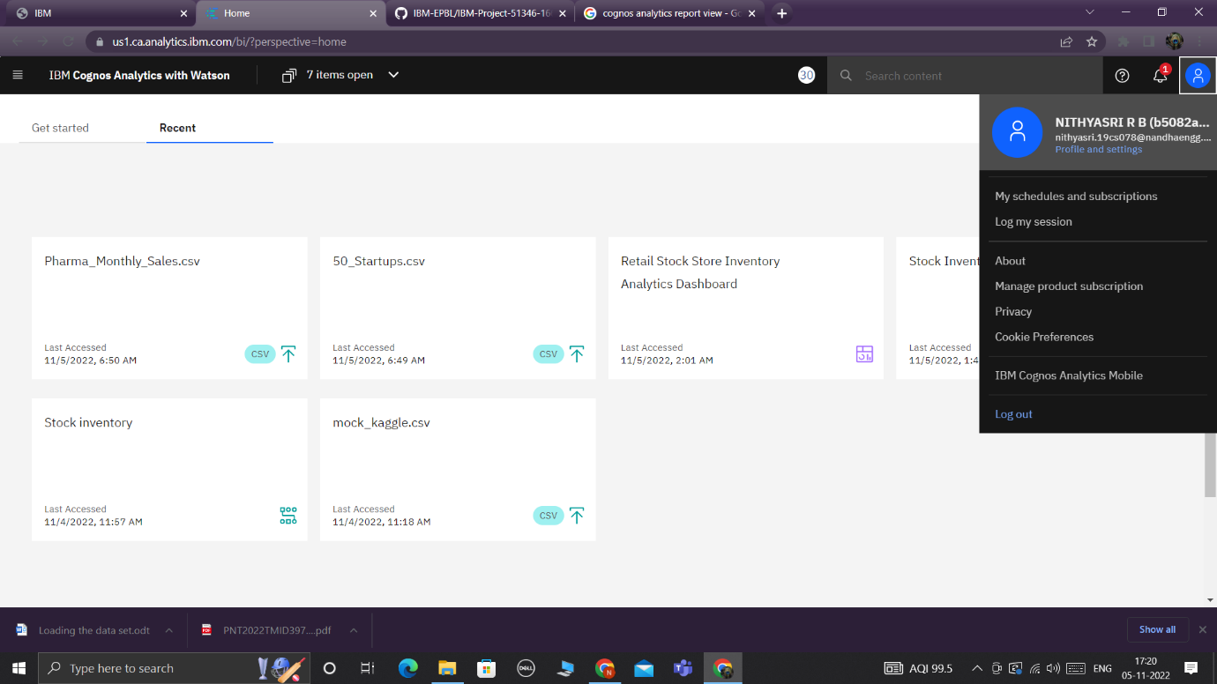

**TEAM MEMBER 1(SIVADHARANI R):**

**IBM COGNOS ACCOUNT:**

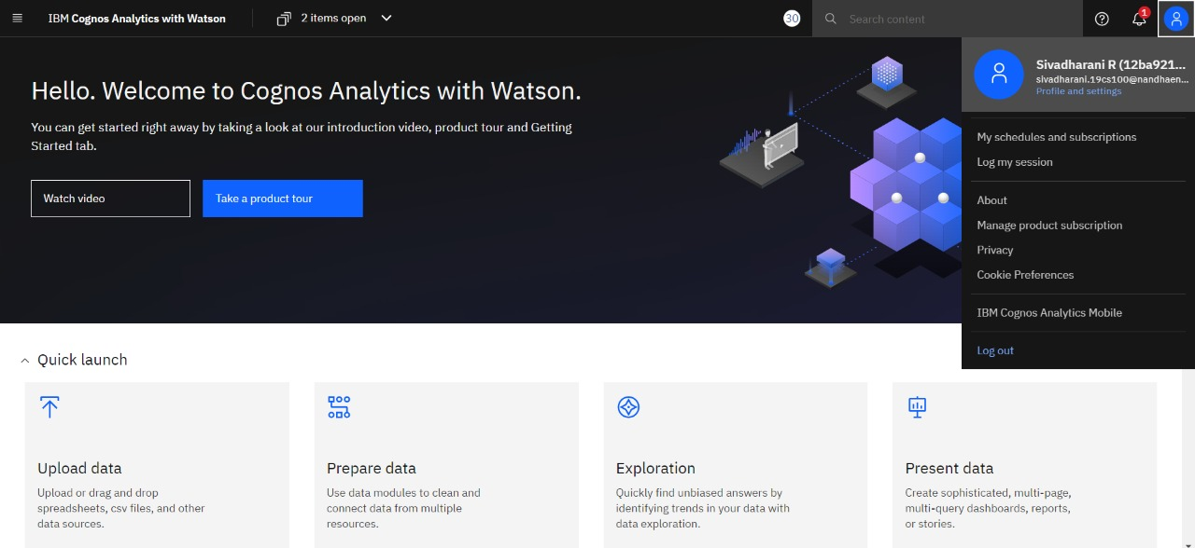

**TEAM MEMBER 2(POOVIZHI M):**

**IBM COGNOS ACCOUNT:**

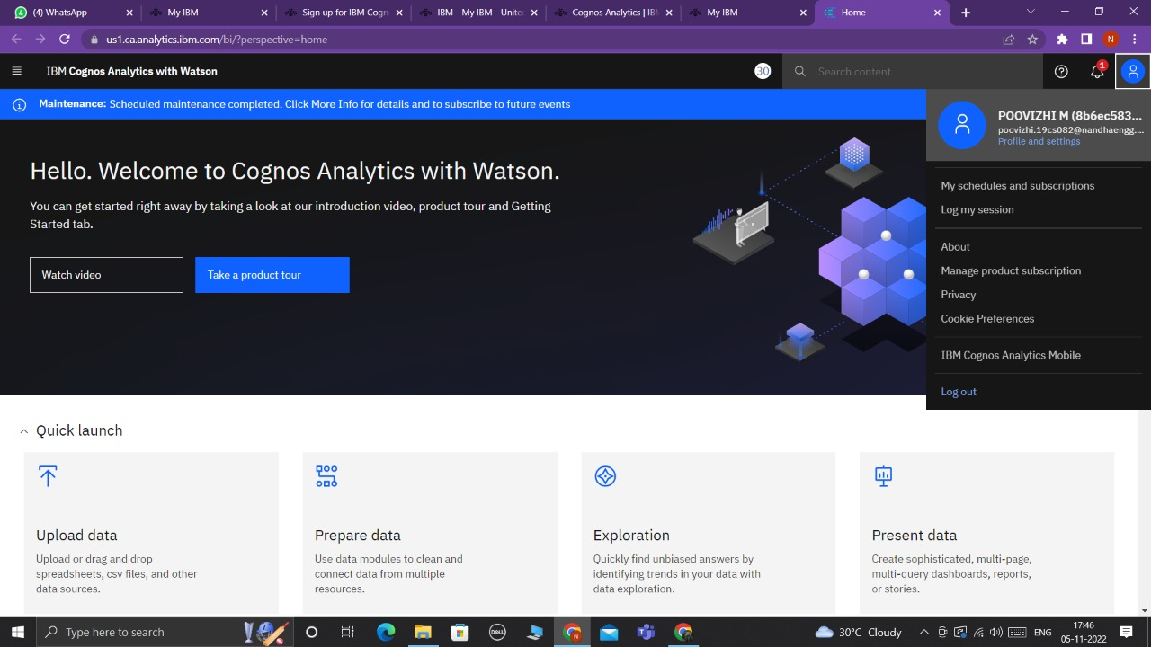

**TEAM MEMBER 3(SARAN KUMAR S):**

**IBM COGNOS ACCOUNT:**

